Driver Drowsiness Detection System Using YoloV5

| *Rishabh Patil Department of Computer Science and Engineering*  *(Data Science) Dwarakadas J. Sanghvi College of Engineering,*  *rishabhpatil9179*[*@gmail.com*](mailto:pkhush2823@gmail.com) | *Saksham Jha Department of Computer Science and Engineering*  *(Data Science) Dwarakadas J. Sanghvi*  *College of Engineering, sakshammohitjha*[*@gmail.com*](mailto:mehtaneil19@gmail.com) | *Mrs. Pooja Vartak*  *Department of Computer Science and Engineering*  *(Data Science)*  *Dwarakadas J. Sanghvi*  *College of Engineering,* [*pooja.vartak@djsce.ac.in*](mailto:pooja.vartak@djsce.ac.in) |  |
| --- | --- | --- | --- |

***Abstract* - In today's society, drowsiness and fatigue have become prominent factors contributing to road accidents. These risks can be effectively mitigated by ensuring sufficient sleep, consuming caffeine, or taking breaks when signs of drowsiness manifest. Currently, complex methods such as EEG, ECG, steering wheel angle, and steering wheel pressure sensors are commonly employed to detect drowsiness. Despite their high accuracy, these methods rely on contact-based measurements and have limitations in monitoring driver fatigue and drowsiness in real-time driving scenarios. Consequently, they are not ideal for immediate use while driving. This research introduces an alternative approach that utilizes the rate of eye closure and the occurrence of yawning as indicators of drowsiness in drivers. The paper outlines a methodology for identifying the eyes and mouth in videos or images, extracting relevant features from the visual input, and determining whether the driver is drowsy or alert. The proposed system focuses on the facial region captured in the video or image, specifically targeting the eyes and mouth. By identifying the face, the eyes and mouth can be detected, facilitating eye and mouth state assessment as well as yawn detection. The parameters for eye and mouth detection are derived from the facial image itself. The video is transformed into individual frames, enabling the localization of the eyes and mouth within each frame. Once the eyes are located, features from the eye area and the overall face region are extracted to determine if the eyes are open or closed, while also extracting a yawn score. If the eyes are identified as closed for a certain duration, such as four consecutive frames, it confirms that the driver is in a drowsy state.**

1. INTRODUCTION

One of the most common reasons for road accidents is driver drowsiness and fatigue and the number of such accidents worldwide is ever increasing. The aim of the paper is to lessen the number of such accidents thereby increasing transportation safety. Driver drowsiness detection is a technology in vehicles that is critical in preventing accidents and saving lives when the drivers are getting drowsy. Computer vision is being used for the detection of the driver’s drowsiness. This report aims to raise awareness about the significance of this technology and encourages its implementation in all vehicles to prevent accidents caused by driver drowsiness and fatigue.In the modern era, transportation is an integral part of daily life for nearly everyone around the world. People utilize various modes of transportation, whether it be private vehicles or public transit.

Regardless of social status, there are rules and codes of conduct that apply to all drivers. One crucial aspect is the need to remain alert and attentive while operating a vehicle. Neglecting these responsibilities towards safe travel has resulted in countless accidents each year. Although some may perceive these rules as insignificant, adhering to them is of utmost importance.On the road, an automobile possesses significant power, and when placed in the hands of irresponsible individuals, it can lead to accidents that affect the lives of everyone in and around the vehicle. Disregarding one's tired state as a driver is a form of carelessness. Recognizing the potential for devastating consequences, many researchers have dedicated their efforts to developing driver drowsiness detection systems. However, there are instances where the accuracy of these systems' observations and findings falls short.Therefore, the purpose of this paper is to provide data and alternative perspectives on this pressing issue. It aims to improve the implementation of driver drowsiness detection systems by enhancing their accuracy and optimizing their effectiveness. The goal is to contribute to the ongoing efforts to address this problem and promote safer driving practices.

The remainder of the current manuscript is structured as follows: Section II provides an extensive review of recent notable research papers on the problem, as well as the traditional approaches that have been employed to address it. Section III outlines the methodology employed in this study, including the design and analysis of the model pipeline. Section IV provides comprehensive information about the dataset, presents the model's performance, and showcases the results obtained from various test cases. Section V discusses the future potential of the proposed solution. Section VI summarizes the conclusions drawn from this study. Finally, Section VII includes a list of references utilized in the paper.

1. LITERATURE REVIEW

Authors Xiao, Bao, and Yan propose a novel approach for detecting yawning behavior. The authors utilize Gabor wavelets, a type of mathematical function, to extract relevant features from facial images. These features are then fed into a classification algorithm called Linear Discriminant Analysis (LDA) to differentiate between yawning and non-yawning instances. [1]

Authors Yin, Fan, and Sun proposes a driver fatigue detection system that utilizes multiscale dynamic features. The authors propose a method that captures and analyzes various temporal scales of driver behavior, enabling the

detection of subtle fatigue-related changes. By extracting and combining these dynamic features, such as eye movement patterns and head pose variations, the system aims to accurately identify driver fatigue levels [2]

Authors Akin, Kurt, Sezgin, and Bayram focuses on estimating the vigilance level of individuals through the analysis of EEG (electroencephalography) and EMG (electromyography) signals. The authors propose a method that combines these two types of physiological signals to assess the level of alertness and attentiveness in individuals. By analyzing the patterns and characteristics of the EEG and EMG signals, the system aims to provide an objective measure of vigilance, which can be useful in various domains, including driver monitoring, workplace safety, and human-machine interaction.[3]

Authors Khushaba, Kodagoda, Lal, and Dissanayake propose a method for classifying driver drowsiness based on a fuzzy wavelet-packet-based feature extraction algorithm. The authors aim to accurately identify drowsy states by extracting relevant features from physiological signals such as EEG and EOG (electrooculography). By utilizing wavelet packets and incorporating fuzzy logic techniques, the proposed algorithm enhances the discriminative power of the extracted features [4]

Authors Hu and Zheng propose a method for detecting driver drowsiness using eyelid-related parameters and support vector machine (SVM) classification. The authors propose using features extracted from eye-related measurements, such as eyelid closure duration and blink frequency, to assess the drowsiness level of drivers. These features are then fed into an SVM classifier for accurate drowsiness detection [5]

Authors Lew, M.; Sebe, N.; Huang, T.; Bakker, E.; Vural, E.; Cetin, M.; Ercil, A.; Littlewort, G.; Bartlett, M.; Movellan, J. Drowsy propose a novel approach to detecting drowsy drivers by analyzing facial movements. The authors propose a human-computer interaction system that utilizes computer vision techniques to monitor and interpret facial expressions and movements in real-time.The proposed system utilizes non-intrusive cameras placed inside the vehicle to capture the driver's facial movements continuously. The captured video data is then processed using computer vision algorithms, which extract facial landmarks, such as eye blinks, yawning, and head movements, as well as the overall facial expression.[6]

Authors Shen, W.; Sun, H.; Cheng, E.; Zhu, Q.; Li, Q focuses on addressing the challenge of monitoring driver fatigue in low light conditions. The authors propose a system that combines pupil detection and yawning analysis techniques to accurately detect signs of fatigue in drivers.[7]

Authors Liu, J.; Zhang, C.; Zheng, C introduces a method for estimating mental fatigue based on electroencephalography

(EEG) signals. The research is published in the Biomedical Signal Processing and Control journal.The proposed approach combines two key components: Kernel Principal Component Analysis (KPCA)-Hidden Markov Model (HMM) and complexity parameters. KPCA is utilized to reduce the dimensionality of the EEG data and extract relevant features that represent the underlying brain activity patterns. HMM is then employed to model the temporal dynamics of mental fatigue based on the extracted features.[8]

Authors Sharma and Vatsa propose a comprehensive overview of driver drowsiness monitoring systems. The authors present a review of various approaches and techniques used in the field of drowsiness detection, including physiological measurements, behavioral monitoring, and computer vision-based methods. The paper highlights the challenges and advancements in this area, discussing the strengths and limitations of different approaches. It also provides insights into the future directions and potential applications of driver drowsiness monitoring systems.[9]

Authors Qu, Wang, Hong, and Li propose a comprehensive review of machine learning techniques for driver drowsiness detection. The authors provide an overview of different machine learning algorithms employed in this domain, including support vector machines, random forests, neural networks, and ensemble methods. The paper discusses the features used for drowsiness detection, such as physiological signals, behavioral cues, and vehicle dynamics. It also evaluates the performance of various machine learning models and highlights the challenges and future directions in driver drowsiness detection research.[10]

Authors Mehranian and Moradi propose an extensive overview of real-time drowsiness detection systems for drivers. The authors present a comprehensive review of various components and techniques used in these systems, including data acquisition methods, feature extraction approaches, and classification algorithms. They discuss different types of sensors and data sources utilized, such as eye-tracking devices, EEG, EOG, and steering wheel sensors. The paper also covers the evaluation metrics used to assess the performance of drowsiness detection systems and highlights the challenges and future directions in this field [11]

Authors Pattanaik, Ghosh, and Roy propose a comprehensive survey of drowsy driver detection systems. The authors provide an overview of various techniques and methodologies used in these systems, including the

physiological measurements, computer vision-based methods, and machine learning approaches. The paper discusses the features and sensors employed for drowsiness detection, such as eye-related parameters, facial expressions, and steering wheel movements. It also explores the [12]

Authors Li, Zhang, and Wang propose a comprehensive survey of driver drowsiness detection methods. The authors present an overview of different approaches used for drowsiness detection, including physiological-based methods, behavioral-based methods, and multimodal approaches that combine multiple modalities. The paper discusses the various sensors and features utilized in drowsiness detection systems, such as EEG, EOG, facial expressions, and vehicle dynamics. It also examines the algorithms and techniques employed for drowsiness classification, including machine learning, deep learning, and fuzzy logic.[13]

Authors, Y. Sun, J. Yang, and C. Zhang, propose a comprehensive survey of the methods and techniques used for drowsiness detection in the context of driving safety. The survey covers a wide range of drowsiness detection methods and techniques. It discusses both physiological-based approaches, which utilize physiological signals such as electroencephalography (EEG), electrooculography (EOG), and heart rate variability (HRV), and behavioral-based approaches, which analyze driver behavior and characteristics such as eye movements, head pose, facial expressions, and vehicle dynamics.[14]

Authors Ba and Tuan propose an in-depth review of driver drowsiness detection systems. The authors present an extensive overview of the various components and techniques used in these systems, including data acquisition methods, feature extraction approaches, and classification algorithms. They discuss different modalities employed, such as physiological signals (e.g., EEG, EOG), behavioral cues (e.g., eye movements, head pose), and vehicle dynamics. The paper also covers the fusion techniques used to integrate multiple modalities for improved accuracy. Additionally, it highlights the challenges, evaluation metrics, and future research directions in the field of driver drowsiness detection.[15]

Authors Wang, Li, Zhu, and Shi propose a comprehensive review of recent developments and future prospects in driver drowsiness detection systems. The authors discuss the importance of driver drowsiness detection systems in reducing road accidents and improving traffic safety. They provide an overview of various sensors and algorithms used in these systems, including physiological sensors, environmental sensors, and machine learning algorithms. The paper also covers the challenges in designing driver drowsiness detection systems, such as individual differences in driving behavior and physiological responses, and the need for real-time detection [16].

Authors, H. Alhichri and F. Brémond" propose a comprehensive review of the recent advancements in systems and technologies for driver drowsiness detection. The review covers a wide range of systems and technologies used for driver drowsiness detection. It explores various sensor modalities and data acquisition techniques employed in these systems. The authors discuss contact-based sensors, such as electroencephalography (EEG), electrooculography (EOG), and electromyography (EMG), as well as non-contact sensors like infrared cameras and steering angle sensors. They highlight the advantages and limitations of each sensor type and discuss their suitability for real-world applications.[17]

Authors, Li, Zhang, and Zhang (2020) propose an innovative approach to detect driver drowsiness by combining electroencephalography (EEG) and peripheral physiological signals. The authors propose a system that integrates these signals to improve the accuracy of drowsiness detection, which is crucial for ensuring road safety. The paper details the data acquisition process, preprocessing steps, feature extraction methods, and fusion techniques used to derive meaningful features for drowsiness detection. Machine learning algorithms are employed for classification, and the system's performance is evaluated using real driving scenarios.[18]

Authors, Zhang, Song, He, and Wu (2021) introduces a method for driver drowsiness detection by employing multi-modal deep learning techniques. The authors describe the data collection process, feature extraction methods, and the architecture of the multi-modal deep learning model. They discuss the advantages of using deep learning techniques, such as convolutional neural networks (CNNs) and recurrent neural networks (RNNs), in handling the complexity and variability of the input data.[19]

Authors Olmos, Villalobos, Cazzato, and De Stefano (2020) presents a real-time system for detecting driver drowsiness using eye tracking and face monitoring techniques. The authors propose a method that combines these modalities to accurately identify drowsiness and enhance road safety.The paper outlines the methodology employed in the system, which involves tracking the driver's eye movements and monitoring their facial expressions.[20]

Authors Singh, Jain, and Sharma (2021) addresses the important topic of driver drowsiness and its implications for road safety. The authors delve into the causes and consequences of drowsy driving, discussing the various factors that contribute to driver fatigue. They also explore existing techniques and technologies used for drowsiness detection and propose potential solutions to mitigate the risks associated with drowsy driving.[21]

Authors, Trivedi, Rathi, Koshorekumar, and Chandra introduce a real-time system for drowsiness detection based on blink frequency estimation using head-pose data. Recognizing the critical importance of timely detection of driver drowsiness to prevent accidents, the authors propose a method that leverages head-pose information to estimate blink frequency, which serves as an indicator of drowsiness.[22]

Authors Zhang, Li, propose a study on driver drowsiness detection using multimodal information fusion. The authors propose a framework that combines multiple modalities, including physiological signals, facial expressions, and vehicle dynamics, to improve the accuracy of drowsiness detection. They explore the integration of different sensor technologies, such as EEG, EOG, video cameras, and steering wheel sensors, to capture diverse aspects of driver behavior and physiological responses.[23]

Authors, Navaz and Aljaaf propose a study on driver drowsiness detection using a deep learning approach with multi-modal features. The authors propose a framework that leverages various data sources, including physiological signals, facial expressions, and vehicle dynamics, to detect driver drowsiness accurately. [24]

Authors, Kanchan and Rautaray (2021 )addresses the issue of driver drowsiness and proposes a system for its detection using deep learning techniques The authors present a method that utilizes convolutional neural networks (CNNs) to analyze facial features and detect signs of drowsiness in real-time.[25]

Authors Shereef, S. A., Fahmy, M. H., and Abd El-Samie, F. E., introduces a drowsiness detection system based on the YOLO (You Only Look Once) algorithm.The paper addresses the critical issue of driver drowsiness and proposes a novel approach to detect drowsiness using computer vision techniques. The authors employ the YOLO algorithm, which is a popular real-time object detection framework, to identify and track facial features indicative of drowsiness.The system utilizes a camera to capture the driver's face and employs YOLO to detect relevant facial regions, such as the eyes and mouth. By monitoring these regions, the system can identify specific signs of drowsiness, such as eyelid closures or prolonged periods of inactivity, and issue appropriate alerts or warnings to the driver.[27]

Authors, Orban, Raouzaiou, Karpouzis, and Kollias (2013) focuses on the detection of laughter and yawning in spontaneous spoken interactions for automatic human affect recognition The paper presents a comprehensive analysis of the computational techniques used for laughter and yawning detection, including facial feature extraction, machine learning algorithms, and the integration of audio-visual cues.[28]

Authors Yazdani, S., Chen, F., and Dhall, A. introduces a new dataset called SMILY, which focuses on the automatic detection and classification of spontaneous multimodal laughter and yawning.The paper addresses the need for datasets that specifically target spontaneous laughter and yawning, as these expressions play a crucial role in human affect recognition and emotion understanding. The authors collected the SMILY dataset, which consists of audiovisual recordings capturing natural instances of laughter and yawning in various scenarios.The dataset includes synchronized audio and video data, allowing for multimodal analysis. The authors also provide ground truth annotations for each instance of laughter and yawning, enabling the development and evaluation of automatic detection and classification algorithms.[29]

Authors,Canavan, Lucey, and Tzimiropoulos addresses the task of detecting laughter and yawning in visual data. The authors propose a method that learns discriminative and shareable features specifically tailored for these two facial expressions.The paper discusses the feature extraction process, which involves deep convolutional neural networks (CNNs) and feature fusion techniques. By training the network on a large dataset, the proposed method aims to capture the unique characteristics of laughter and yawning while also identifying common features that can be shared between the two expressions.[30]

Research Gaps:

Yawning detection based on Gabor wavelets and LDA:Limited robustness in yawning detection under varying lighting conditions or complex backgrounds

Multiscale dynamic features based driver fatigue detection:Insufficient consideration of real-time implementation and practical deployment of the fatigue detection system.

Estimating vigilance level by using EEG and EMG signals:Limited focus on incorporating visual cues or facial expressions as additional indicators of vigilance level.

Driver drowsiness classification using fuzzy wavelet-packet-based feature extraction algorithm: Limitations in accurately extracting discriminative features from wavelet packets for drowsiness classification

Limited detection capabilities: The existing drowsiness detection systems rely on traditional computer vision algorithms or simple feature-based approaches, which struggle to accurately detect signs of drowsiness

1. METHODOLOGY

The proposed model’s advanced detection capabilities to improve the accuracy and robustness of facial landmark detection, allowing for more precise identification of key indicators of drowsiness, such as eye closure or facial movements. Its optimized architecture and implementation enable fast and efficient real-time object detection, facilitating prompt detection of drowsiness-related cues and timely interventions to prevent accidents. The model can handle diverse environments which makes it well-suited for driver drowsiness detection. Its robustness to variations in lighting and background can improve the system's performance across different driving scenarios. It could be utilized to detect and analyze facial expressions associated with drowsiness or fatigue, providing complementary information to EEG and EMG signals for a more comprehensive estimation of vigilance level.

3.1 Technology Used

Maksense.ai

Makesense.ai offers data labeling services that help businesses and organizations improve the accuracy and performance of their machine learning models. Data labeling is the process of manually annotating data to create a training set for machine learning algorithms. Makesense.ai provides a range of data labeling services, including image annotation, text annotation, and audio transcription. The platform uses advanced machine learning algorithms to ensure accurate and consistent labeling, and also offers quality assurance and validation services to ensure high-quality data. Makesense.ai's data labeling services are designed to help businesses and organizations save time and resources, while also improving the accuracy and performance of their machine learning models.

YOLOv5

YOLO, short for "You Only Look Once," is a real-time object detection system that operates by dividing an image into a grid. It then predicts bounding boxes and class probabilities for each grid cell. YOLOv5 incorporates a neural network architecture specifically engineered to offer improved speed and accuracy compared to earlier iterations of YOLO.The YOLOv5 model is available in several different versions, including small, medium, large, and extra-large, with each version offering varying levels of accuracy and performance. YOLOv5 boasts a notable capability to detect objects with diverse sizes and aspect ratios, making it an invaluable asset for numerous computer vision applications. Its versatility extends to fields such as autonomous vehicles, robotics, and surveillance. Through training on multiple benchmark datasets, the model has consistently demonstrated cutting-edge performance across various tasks, including object detection, instance segmentation, and image classification. This highlights YOLOv5's effectiveness and potential for driving advancements in the field of computer vision.

The YOLOv5 architecture consists of a backbone network, a neck network, and a head network. The backbone network is responsible for extracting high-level features from the input image. YOLOv5 uses a variant of the EfficientNet backbone, which is known for its efficiency and accuracy.The neck network, also known as the FPN (Feature Pyramid Network), is responsible for capturing features at multiple scales. It enhances the model's ability to detect objects of various sizes and aspect ratios. The FPN achieves this by combining features from different levels of the backbone network.The head network is responsible for generating predictions based on the features extracted by the backbone and neck networks. It predicts bounding box coordinates and class probabilities for multiple objects simultaneously. YOLOv5 uses anchor boxes of different sizes and aspect ratios to improve the detection of objects at different scales.

Two models are created, each for one aspect of drowsiness calculation that is:

* Eyes Position: Open or Close
* Yawning: Yawn,Laugh or No yawn

The training dataset consists of 1200 images, for each aspect which is annotated using Makesense.ai. A custom YOLOv5 Model is created for each aspect. The model is trained for 200 epochs. For each aspect, YOLOv5 finds the probability for the aspect being classified, the probability is used to define the driver’s drowsiness.

* The probability of the driver being drowsy is calculated based on both these methods and trigger the alarm accordingly.
* Combining the Output of model 1(Eye) and model 2(Mouth) taking weighted average of both and gives a combined output of whether the person is sleepy or not
* eSpeak module (text to speech synthesizer) is used for giving appropriate voice alerts when the driver is feeling sleepy

3.2 Design and Analysis

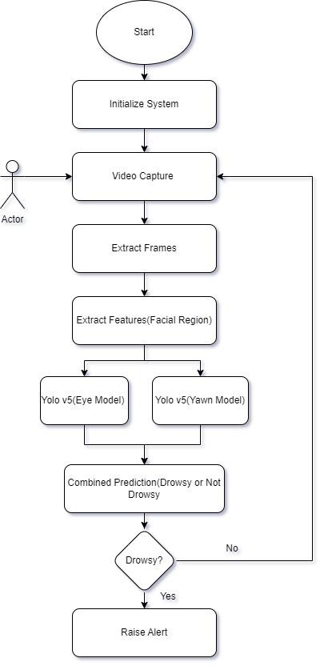

# Fig. 1 Pipeline

By implementing this pipeline, the paper aims to achieve efficient and accurate predictions on full face images, utilizing various techniques and libraries to enhance the performance of the system.Initially, the system is initialized, and the user's video is captured using a webcam or an infrared camera to enhance the accuracy of detecting the region of interest, which is the facial region. Each frame of the video is extracted using the OpenCV cv2 library. Additionally, the dlib library is utilized for face detection within the image. Next, face alignment is carried out using the FaceAlignment class from the imutils.face_utils library to enhance the accuracy of eye and yawn detection. Furthermore, the background is blurred using a Gaussian blur technique. Subsequently, eyes and yawn detection are performed. In the preprocessing stage, the region of interest (ROI) within the image is extracted and passed to the model for prediction.The preprocessed frame is then fed into the model, which has been trained on 1200 images to predict the eyes and facial region. The output of each frame is saved using a counter. If the driver is determined to be drowsy based on a certain number of consecutive frames, the system will generate an alert to notify the driver of their drowsiness.

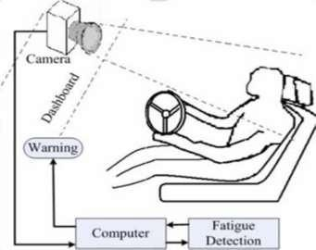

Fig.2 Architectural Design

* Input Image: The image or video containing the driver's facial region is given to the system to be evaluated. The image or video can be in any valid format. The input is then given to the Computer block
* Computer: The Computer involves the two Yolov5 model for each aspect of drowsiness detection and is trained on a 1200 image dataset and tested on a batch size of 60 to improve accuracy and not overfit the data
* Fatigue Detection: The process consists of a pipeline which preprocesses the image into various regions of interest such as region of mouth, eyes. Each segmented part of the equation is now fed to the previously trained Yolov5 model, which classifies the image as part of a specific class, recognizing what it is and returns the probability of belonging to that class.
* Output Generation/Warning: Once all outputs are recognized, the probabilities of classes are combined and a cumulative prediction will be given whether the person is drowsy or awake for that frame and thus if the output is persistent for a particular period of time the alarm will be raised.

1. RESULT AND EXPERIMENT

4.1 Design and Analysis

# The paper uses a Custom Dataset. There are 2 Custom dataset for each aspect of drowsiness which are Eyes and Mouth. The Eyes dataset contains two classes for classifying images into Open Eyes, Closed Eyes , the Yawn dataset contains three classes namely yawn,no yawn and laugh

# 

# Fig. 3 Yawn Dataset Instances

# 

# Fig 4 Eyes Dataset Instances

Characteristics of the dataset are as follows(for both eyes and mouth model)

* The custom dataset contains a total of 1200 images in two categories.
* Each category has almost 600 images.
* The dataset is uniformly distributed to ensure there is no biases towards a one particular class
* Class Labels — Open Eye and Closed Eye(for Eye model)
* Class Labels — Yawn,Laugh and No_yawn(for Mouth model)
* Class Labels were annotated using the application makesense.ai

4.2 Preprocessing

* Gaussian Blur: In the context of driver drowsiness detection, Gaussian Blur can be beneficial in enhancing the accuracy of subsequent facial feature extraction and tracking algorithms. It helps to eliminate small imperfections, such as camera sensor noise or minor facial movements, that may interfere with the detection and tracking of critical facial regions like the eyes or mouth.
* Face-Aligner: In This Output coordinate space, all faces across an entire dataset should be centered in the image, be rotated such that the eyes lie along the same y-coordinates and the image be scaled such that the size of the faces are approximately identical

4.2 Performance of the Model

The following Performance Metrics are used —

* Accuracy vs. Number of Epochs Plot
* Loss vs. Number of Epochs Plot
* Confusion Matrix
* F1 Confidence Curve
* Recall Confidence Curve

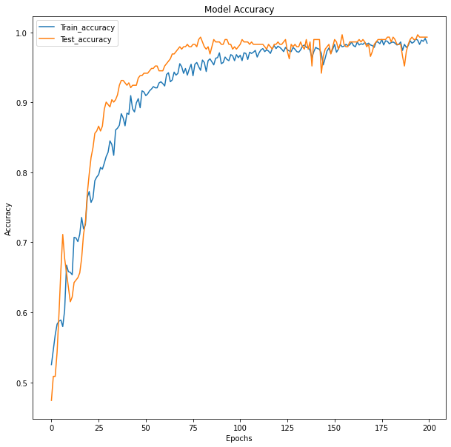

Fig.5 Accuracy vs Number of Epochs

# In Fig 5 The testing and training accuracy of the model coincide after 200 epochs. The inference it can be inferred that the the model has not overfit on the training dataset

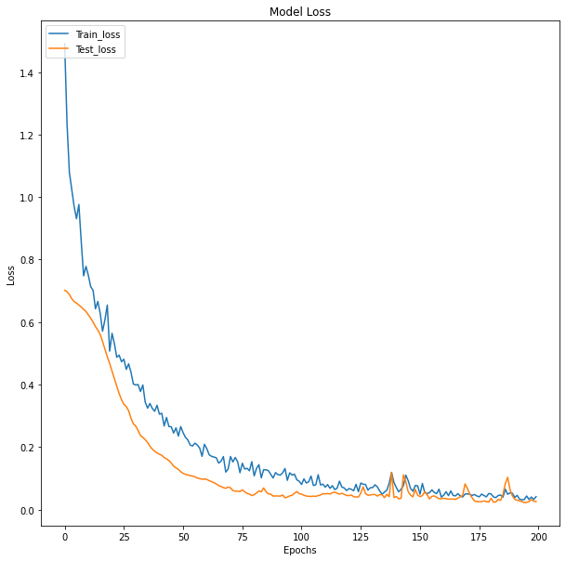

Fig.6 Loss vs. Number of Epochs

# The loss of both training and testing keeps reducing and no point the testing loss increases which describes the model as not overfitted

# 

Fig.7 Confusion Matrix

# The Confusion matrix depicts that the number of false positive and false negative is less than 2 in a testing dataset of 300 which gives us high accuracy in the testing phase

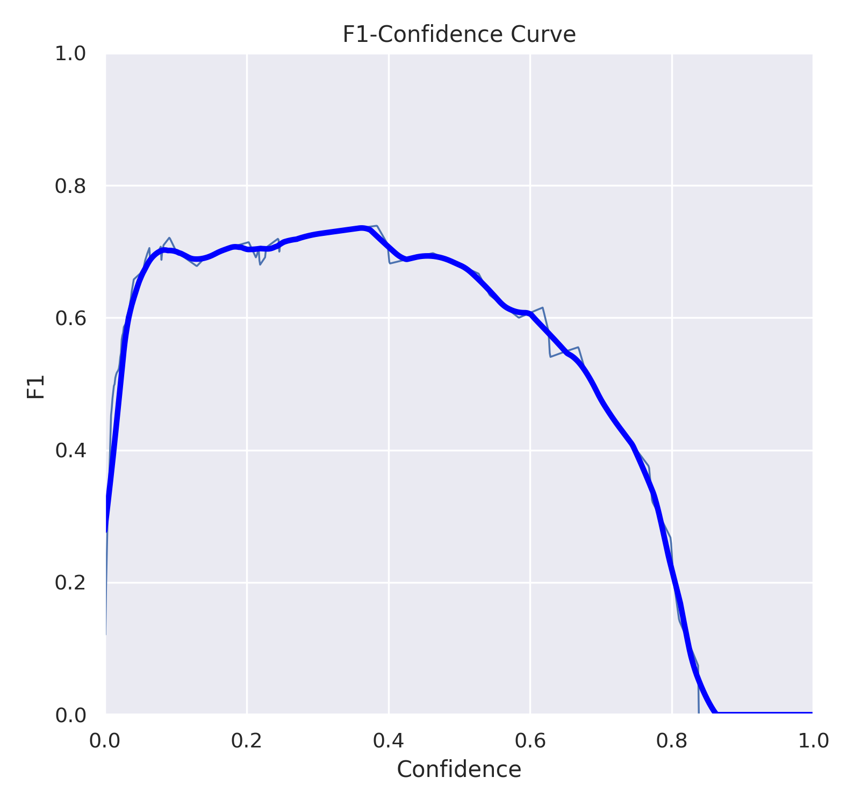

Fig.8 F1 Confidence Curve

# In Fig.8 The F1 Confidence Curve depicts that for a confidence value between 0.1 to 0.8 for an F1 score close to 0.7 which is a desirable result for a optimum model a similar line is obtained for our testing dataset which means that the model captures only the relevant features in the dataset and is not overfit

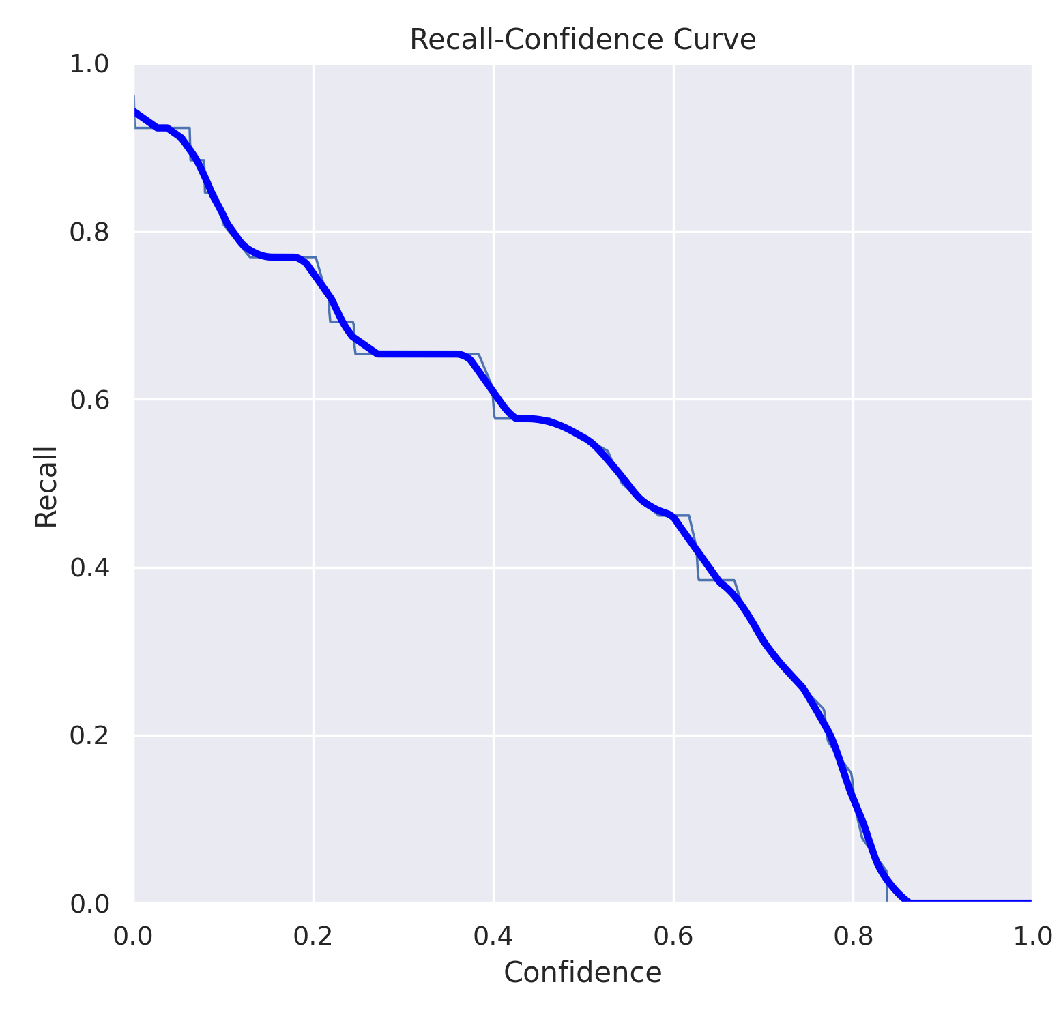

Fig.9 Recall Confidence Curve

# 

# In Fig9. The Recall Confidence Curve depicts that the AUC(area under the curve) For the training and testing Dataset and it predicts a similar trend line

From the above Result Analysis the model is capable on predicting on real word images which can give us appropriate output

# 

4.2 Result and Discussion

# Following are the results of the model for various test cases

The model's performance on different drivers and scenarios can vary depending on various factors. Here are some possible outcomes:

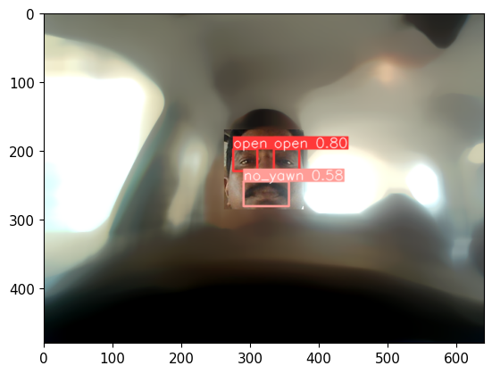

Fig.10: Image With Gaussian Blur

In Fig.10 as the mouth of the Driver is closed the Model predicts the No_yawn with 58% and both the eyes as open with 80% probability.The noisy background is blurred using Gaussian Blur and face is detected and aligned using haar cascade filter and im.utils face aligner

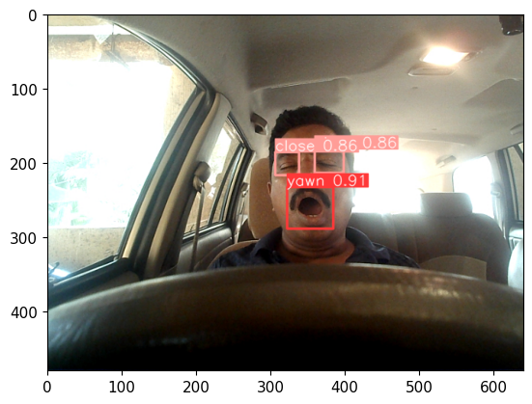

Fig.11:Image Without Gaussian Blur

In Fig.11 the Gaussian Blur Filter is removed but the model is still able to classify the eyes and yawn with a high probability of 86% and 91% respectively

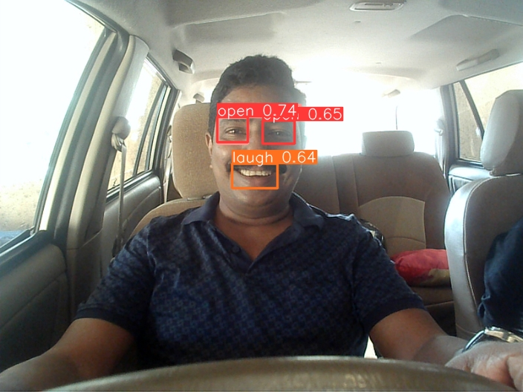

Fig.12: Driver Laughing

In Fig.12 the Driver is laughing and the Model predicts the Laugh with 64% probability and both the eyes as open with 74% and 65% probability.

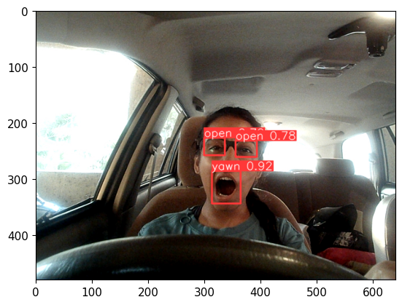

Fig.13: Driver Wearing Glasses

In Fig.13 the Driver is wearing glasses the model still predicts the driver eyes with a probability of 78% and the yawn with 92%

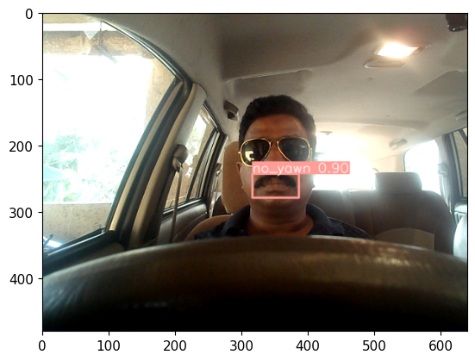

Fig.14: Driver Wearing Goggles

In Fig.14 the Driver is Wearing Goggles which is why the model is not able to predict the eyes probability but since the mouth region is still visible our model give the prediction for no_yawn with high probability of 90%

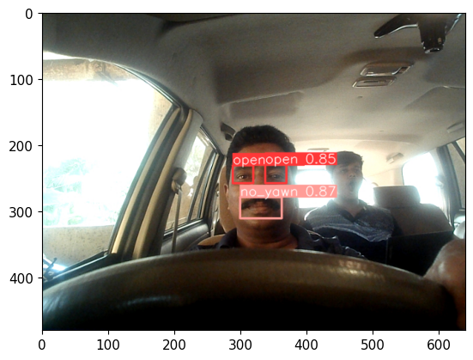

Fig.15:Driver along with Passenger Yawning

In Fig.16 it can be observed that even though the passenger behind the driver is yawning the model does not detect it as a yawn and only detects the driver's drowsiness. This happens because of the preprocessing done in this frame with includes blurring(only detects the most probable face) and face alignment

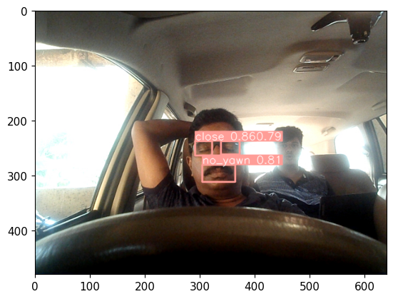

Fig.16:Driver sleeping and Passenger Awake

In Fig16 only Driver Drowsiness condition is still detected with a high probability with both eyes closed being detected at almost 80% and yawning with 81% despite the passenger being in the frame and awake.

V FUTURE SCOPE

In future research, there is potential to explore the incorporation of external factors such as vehicle states, sleep patterns, weather conditions, mechanical data, and more in measuring fatigue. Driver drowsiness presents a significant threat to highway safety, particularly for commercial motor vehicle operators. Factors such as round-the-clock operations, extensive annual mileage, exposure to challenging environmental conditions, and demanding work schedules contribute to this critical safety issue.Monitoring the drowsiness and vigilance levels of drivers and providing feedback on their condition to prompt appropriate action is a crucial step in a comprehensive approach to address this problem. Currently, there is no adjustment in terms of camera zoom or direction during operation. Future work could involve automatically zooming in on the eyes once they have been localized, further improving the accuracy and effectiveness of drowsiness detection systems.With the integration of Advanced Driver Assist Systems (ADAS), car companies have access to a wealth of data concerning driver driving patterns. This data can be analyzed to identify patterns that indicate driver drowsiness, in addition to the information provided by existing sensors such as steering wheel angle and steering pressure sensors. The image-based model can further contribute to the determination of driver drowsiness.By examining driver behavior and driving patterns while drowsy, such as frequent lane changes on highways or delayed braking, a drowsiness pattern can be inferred from the Image model. Analyzing images can provide valuable insights into the driver's drowsiness state, augmenting the existing sensors' capabilities.By combining the data from ADAS and the image-based model, a comprehensive understanding of driver drowsiness can be achieved, enabling proactive measures to prevent accidents and promote road safety.

VI CONCLUSION

Two drowsiness detection models have been developed, both capable of effectively detecting drowsiness in drivers. The first model focuses on differentiating between open and closed states of the eyes, while the second model distinguishes between yawn, laugh, and no_yawn states based on a scoring mechanism. Additionally, the yawn model assigns a score specifically for yawns. By combining the outputs of these models, an alarm system is activated, effectively preventing the driver from falling into a state of sleepiness while driving .During monitoring, the system continuously determines the status of the driver's eyes, whether they are open or closed, and evaluates the yawn score against a predefined threshold. The model is designed to differentiate between yawning and other facial movements such as laughing or speaking. This ensures that yawning is accurately detected while minimizing false alarms during normal activities.If the eyes remain closed for a specific duration or if the person yawns for a certain period of time, the alarm system is triggered, alerting the driver to their drowsy state. Additionally, the vehicle's speed is automatically reduced to enhance safety. By implementing such a system, the number of accidents can be significantly reduced, ensuring the well-being of the driver and overall vehicle safety.It is important to note that the system described in the paper is currently only available in luxury vehicles due to its advanced features and associated costs.

VII REFERENCES

1. Xiao, F.; Bao, C.Y.; Yan, F.S. Yawning detection based on gabor wavelets and LDA
2. Yin, B.-C.; Fan, X.; Sun, Y.-F. Multiscale dynamic features based driver fatigue detection
3. Akin, M.; Kurt, M.; Sezgin, N.; Bayram, M. Estimating vigilance level by using EEG and EMG signals. Neural Comput. Appl
4. Khushaba, R.N.; Kodagoda, S.; Lal, S.; Dissanayake, G. Driver drowsiness classification using fuzzy wavelet-packet-based feature extraction algorithm..
5. Hu, S.; Zheng, G. Driver drowsiness detection with eyelid related parameters by support vector machine
6. Lew, M.; Sebe, N.; Huang, T.; Bakker, E.; Vural, E.; Cetin, M.; Ercil, A.; Littlewort, G.; Bartlett, M.; Movellan, J. Drowsy driver detection through facial movement analysis. In Human Computer Interaction; Springer: Berlin, Germany,
7. Shen, W.; Sun, H.; Cheng, E.; Zhu, Q.; Li, Q. Effective driver fatigue monitoring through pupil detection and yawing analysis in low light level environments. Int. J. Digit. Technol. Appl.
8. Liu, J.; Zhang, C.; Zheng, C. EEG-based estimation of mental fatigue by using KPCA-HMM and complexity parameters. Biomed. Signal
9. Sharma, R., & Vatsa, M. (2017). A review of driver drowsiness monitoring systems. Journal of Ambient Intelligence and Humanized Computing, 8(4), 627-64
10. Qu, X., Wang, C., Hong, W., & Li, Y. (2019). Driver drowsiness detection using machine learning: A review. IEEE Access, 7,
11. Mehranian, A., & Moradi, M. H. (2019). Real-time drowsiness detection system for drivers: A comprehensive review. IET Intelligent Transport Systems,
12. Pattanaik, S. K., Ghosh, P., & Roy, P. P. (2018). A survey on drowsy driver detection systems. IETE Technical Review,
13. Li, S., Zhang, Y., & Wang, Y. (2019). Driver drowsiness detection: A survey. Pattern Recognition Letters
14. Sun, Y., Yang, J., & Zhang, C. (2019). Drowsiness detection for driving safety: A survey. IEEE Transactions on Intelligent Transportation Systems
15. Ba, H. Q., & Tuan, N. D. (2020). A comprehensive review on driver drowsiness detection systems. Information Fusion,
16. Wang, X., Li, X., Zhu, Y., & Shi, L. (2020). Driver drowsiness detection system: A review of recent developments and future prospects
17. Alhichri, H., & Brémond, F. (2019). Driver Drowsiness Detection: A Review of Recent Systems and Technologies. Sensors,
18. Li, C., Zhang, Y., & Zhang, G. (2020). A Novel Driver Drowsiness Detection System Based on EEG and Peripheral Physiological Signals. IEEE Access, 8, 224419-224428
19. Zhang, J., Song, S., He, W., & Wu, J. (2021). Driver Drowsiness Detection Using Multi-Modal Deep Learning. IEEE Access, 9, 20271-20280.
20. Olmos, S., Villalobos, W., Cazzato, D., & De Stefano, M. (2020). Real-time driver drowsiness detection based on eye tracking and face monitoring. Pattern Recognition,
21. Singh, S., Jain, A., & Sharma, R. (2021). Driver Drowsiness IEEE Transactions on Intelligent Transportation Systems
22. Trivedi, M. M., Rathi, S., Koshorekumar, A., & Chandra, A. (2020). Real-Time Drowsiness Detection Based on Blink Frequency Estimation Using Head-Pose Data. IEEE Transactions on Intelligent Transportation Systems
23. Li, Y., Tang, Y., Jiang, Z., Zhang, J., & Luo, S. (2021). Driver Drowsiness Detection Using Multi-Modal Deep Learning with Transfer Learning
24. Navaz, A., & Aljaaf, A. J. (2021). Driver Drowsiness Detection using Multi-Modal Features: A Deep Learning Approach. In 2021 International Conference on Internet of Things and Intelligence System (IoTaIS)
25. Kanchan, V., & Rautaray, S. S. (2021). Driver Drowsiness Detection using Deep Learning and YOLO Framework. In 2021 11th International Conference on Cloud Computing, Data Science & Engineering (Confluence) (pp. 253-257). IEEE.
26. Nyein, Y. Y. L., Aung, M. S. M., & Htet, W. W. (2020). Real-Time Drowsiness Detection System for Drivers Using YOLO Algorithm. In 2020 6th International Conference on Advanced Computing and Communication Systems (ICACCS) (pp. 1507-1511). IEEE
27. Shereef, S. A., Fahmy, M. H., & Abd El-Samie, F. E. (2020). Drowsiness Detection System using YOLO Algorithm. In 2020 22nd International Conference on Transparent Optical Networks (ICTON) (pp. 1-4). IEEE.
28. Orban, P., Raouzaiou, A., Karpouzis, K., & Kollias, S. (2013). Detecting laughter and yawning in spontaneous spoken interactions for automatic human affect recognition. Image and Vision Computing
29. Yazdani, S., Chen, F., & Dhall, A. (2021). SMILY: A Spontaneous Multimodal Laughter and Yawning Dataset for Automatic Detection and Classification. In Proceedings of the 2021 International Conference on Multimodal Interaction
30. Canavan, S., Lucey, P., & Tzimiropoulos, G. (2020). Learning discriminative and shareable features for laughter and yawning detection. In Proceedings of the IEEE/CVF Conference on Computer Vision and Pattern Recognition Workshops